IC-05 One Dimensional Motion
Rev 1-1-2023

5.1 OBJECTIVE
The purpose of this Lab is to verify the equations of one-dimensional motion. This will be done by measuring the distance, time and velocity of an object that moves with constant acceleration, and hence calculating the value of acceleration due to gravity by using these equations.

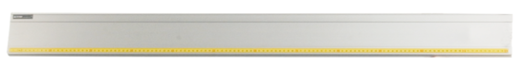
5.2 EQUIPMENT
- Dynamics Track
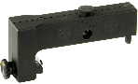
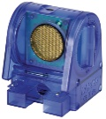
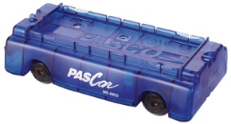
- Dynamics Cart
- Motion Sensor
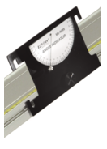
- End Stop
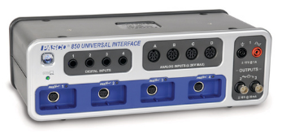
- Lab Jack
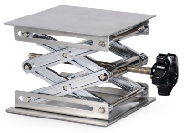
- Protractor / angle indicator / cell phone app.
- PASCO System Science Workshop UI 850
- PASCO Capstone Software

5.3 THEORY
An object in one-dimensional motion under constant acceleration satisfies the following equations of motion:
$v_{x_{f}}= {v_{x}}_{i}+ a_{x} (t_{f}- t_{i})$ (1)
$x_{f}= x_{i}+ v_{x_{i}}\left(t_{f}- t_{i}\right)+\frac{1}{2} a_{x} {\left(t_{f}- t_{i}\right)}^{2}$ (2)
${v_{x_{f}}}^{2}= {v_{x_{i}}}^{2}+ 2 a_{x} (x_{f}- x_{i})$ (3)
Where $x_{i}$ = initial position on the track (at time = $t_{i}$)
$x_{f}$ = final position on the track (at time = $t_{f}$)
${v_{x}}_{i}$ = Initial velocity in the x-direction (at time = $t_{i}$)
$v_{x_{f}}$ = Final velocity in the x-direction (at time =$t_{f}$)
$a_{x}$ = Acceleration in the x-direction (which is constant, not a function of time)
In the absence of air resistance, objects falling under the influence of gravity have a constant downwards acceleration. On and near the surface of the Earth this acceleration has a value of approximately 9.81 m/s² which is denoted by the symbol ‘g’. We will study the distance, time and velocity of an object as it freely falls vertically down, as well as when it slides without friction on an inclined plane, and hence determine its acceleration for the two cases. For an inclined plane, as seen in the figure, the value of acceleration along the plane will be:
g
g Cosθ
θ
g Sinθ
a = g Sin(θ)

Equation (1): $v_{x_{f}}= {v_{x}}_{i}+ a_{x} t_{f}$
Here $v_{xf}$ is the velocity at time $t_{f}$ and $v_{xi}$ is the velocity at time $t_{i}=0$. The equation of a straight line is:
$y=b+mx$
Equation (1) is an equation of a straight line, if we take $v_{xf}$ as the y-axis and $t_{f}$ as the x-axis. The slope of the line “m” will be the acceleration “$a_{x}$”, and the y-intercept “b” is “$v_{xi}$”. From the smart cart we can get the velocities at different times, and plot a graph between $v_{xf}$ on the y-axis and $t_{f}$ on the x-axis. The slope of the line will give us the value of $a_{x}.$ For motion on the inclined plane, it should come out to $a_{x}=9.8 \sin{θ}m/s^{2}$ (with x along the inclined plane).

Equation (2): $x_{f}= x_{i}+ v_{x_{i}}\left(t_{f}- t_{i}\right)+\frac{1}{2} a_{x} {\left(t_{f}- t_{i}\right)}^{2}$
We will measure the position by using the motion sensor. The best fit line for the graph of $x_{f}$ on the y-axis and time on x-axis will yield a parabola. This parabola equation will have form:
$x_{f}=At^{2}+Bt+C$
And acceleration is seen to be equal to 2$A$.

Equation (3): ${v_{x_{f}}}^{2}= {v_{x_{i}}}^{2}+ 2 a_{x} (x_{f}- x_{i})$
Comparing this equation with: y = b + mx, we can see that a plot of ${v_{x_{f}}}^{2}$ on the y-axis Vs position (i.e. $x_{f})$ on the x-axis should come as a straight line with the slope being $2 a_{x}$ and y-intercept being ${v_{x_{i}}}^{2}$.

Equation (4): $a_{x}=g Sin(θ)$
Once the value of acceleration for the cart (i.e. “$a_{x}$”) is obtained, Equation 4 can be used to find the value of “g”. If “g” comes out close to the correct value, that means that “$a_{x}$ “, and hence equations 1, 2, and 3 are correct.
The procedure will involve finding the values of acceleration of the cart i.e. ”$a_{x}"$by the three equations, and from them, finding the value of “g”. If the value of “g” comes out good, then we can assume that $a_{x}$ is good, which means the equations are good.
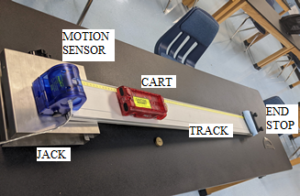
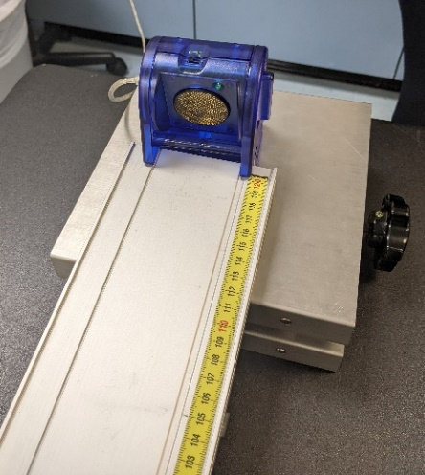

Figure 2: Inclined plane. Figure 3: Motion sensor

5.4 HOW TO USE EQUIPMENT

Motion Sensor
An electrostatic transducer in the face of the Motion Sensor transmits a burst of 16 ultrasonic pulses with a frequency of about 49 kHz. The ultrasonic pulses reflect off the target and return to the face of the sensor. The target indicator flashes when the transducer detects an echo. The sensor measures the time between the trigger and reflected echo rising edges, then, it uses this time and the speed of sound to calculate the object's distance. To determine velocity, it uses consecutive position measurements to calculate the rate of change. It similarly determines acceleration by using consecutive velocity measurements.

5.5 PROCEDURE:
- Connect the motion sensor to the interface Science Workshop 850, then turn on the Capstone software.
- Set up the track so that it is tilted to an angle between 3⁰ to 6⁰. Attach an end-stop at the lower end to prevent the cart from rolling off to the ground. Attach the motion sensor to the higher side, so that it is ‘looking’ down along the track. Set the cart about 10 cm from the motion sensor. See figures 2 and 3.
- Place some soft item just before the end stop to prevent the cart from hitting it.
- Open a graph and set the y-axis to velocity and x-axis to time. You can change the y-axis later to see the position-time and velocity squared-position graphs also.
- Start recording, and let the cart roll down. The system should start and stop recording as programmed in Start and Stop Conditions.
- Click on the “Highlight Range…” icon to get a colored square on the screen. On the graph, move and adjust its size so that a portion of the data that is “good” is inside the box. Then click the icon for Curve Fits.
- Observe the data on the V-T curve. Equation (1) indicates that it should be a straight line. The slope on the V-T curve is the value of acceleration of the cart ‘$a_{x}$’. The value of the regression coefficient i.e. R, indicates how good the data fits the equation chosen. R should be greater than 0.95 for the fit to be acceptable. Note the value of the slope in the data table.
- After testing the system a few times, erase all data and do at least four runs, with at least two different angles, each with a different mass added to the cart, to see the effect of angle and mass on the acceleration and discuss this in your Conclusions.

Equation (1):
- Select Velocity on the Y-axis, and Time on the X-axis.
- Select a “good” range of data. Usually better to avoid the first and last few data points.
- Select “Linear”, and get the slope of the straight line. This is your acceleration of the cart. Use equation 4 to get the value of ‘g’.

Equation (2):
- Now change the variable on the Y-axis to ‘Position’. The data that you have already taken will show on the X-T curve (no need to roll the cart again). Equation (2) indicates that it should be a parabola. Select a ‘good’ range of data, and find the quadratic fit to it. The quadratic fit will give the equation X = At² + Bt + C. The value of acceleration $a_{x}$ of the cart will be equal to 2A. Note the value of acceleration in the data table, and calculate ‘g’ form Eqn. (4).

Equation (3):
- Change the Y-axis back to velocity. Click the icon for Velocity. This will open a box. Select “QuickCalc”. In QuickCalc, select V². Change the X-axis from Time to Position. You now have the V² versus Position graph. Fit a straight line to this and obtain the value of “2$a_{x}$” from the slope. Hence find the acceleration$a_{x}$. Use Eqn. (4) to get ‘g’.

Note:
- 1n the software, instead of manually doing start and stop, you can set up automatic start and stop conditions. Click “Recording Conditions”, and set the start condition to when the cart has moved, say 15 cm, and a stop condition when it has moved, say, 80 cm (these values will depend on the length of your track). Then data recording will begin when the cart has moved 10 cm from the motion sensor, and stop when it reaches 80 cm.
- Make sure you don’t forget to add the end stop, so that the cart does not roll away and fall down. Also don’t let the cart hit the end stop either, by placing some soft material in front of it.

5.6 PRECAUTIONS
- Make sure that the track is not bent in the middle. Add extra support if needed.
- The motion sensor should be set to “cart”, not to “person”.
- Make sure that the Motion Sensor is “looking” at the cart, and not above or below it.
- The Motion Sensor does not work if the object is closer than 15 cm to it.
- The motion sensor should be attached so that it points in the direction of the track. Note that the motion sensor in Figure 3 is slightly tilted and is not correctly placed.
- When selecting the data for the curve fits, do not try to get to the very last data points at either end.
- Measure the angle carefully. The angles are small, and so, even a 0.5° error at 5° may lead to a 10% error in the final result.
- The wheels of the cart should be in the two grooves on the Track.
- The weights added to the cart should not move around the cart while it is moving. Use the “cart weights” that fit into the cart.
- There may be some friction in the wheels of the cart.
- At higher speeds, air resistance may have some effect.

5.7 IC-05 One-Dimensional Motion REPORT FORM

Date: _______________

Inclined Plane

 | T r I a l N u m b e r |  |  |  | Average value of ‘g’ | Percent Error in ‘g’
 | 1 | 2 | 3 | 4
Capstone Run Number |  |  |  |  | X | X
Angle of incline |  |  |  |  | X | X
Mass of the cart (kg) |  |  |  |  | X | X
‘$a_{x}$’ from velocity versus time graph (m/s²) |  |  |  |  | X | X
Value of “g” from ‘$a_{x}$’ by eqn. 4 (m/s²)
‘$a_{x}$’ from the position versus time graph (m/s²) |  |  |  |  | X | X
Value of “g” from ‘$a_{x}$’ by eqn. 4 (m/s²)
‘$a_{x}$’ from the V² vs Position graph (m/s²) |  |  |  |  | X | X
Value of “g” from ‘$a_{x}$’ by eqn. 4 (m/s²)

5.8 RESULTS

 | Found by Inclined Plane in this Lab with
 | X-T Graph | V-T Graph | V²-X Graph
Value of ‘g’ (m/s²)
Percent Error in ‘g’

5.9 REPORT SUBMISSION
Upload the following in the Report for this Lab:

 |  | Points in report
1 | The completely filled up “Report Form”. Make sure to include units of measurements. | 10
2 | Sample Calculations | 5
3 | Graphs from Capstone (at least one for each of the three equations). The graphs should show selected data and curve fit equation. All text in graphs should be legible (make sure the size is not too small). | 3*5 = 15
4 | Sources of Error in this experiment. | 5
5 | Discussion of your results | 10
 | Total | 45
Make “Sources of Error” and “Discussion” as two separate headings.
Extra Credit: Uploading a short video of your experiment being performed will get you 5 points extra credit. Video should show your equipment, you performing the experiment (or a part of it), and the resulting graphs on capstone.

5.10 ADDITIONAL INFORMATION
See these videos for additional information on this experiment.
Motion Sensor (2:22 min) https://youtu.be/DByy342m60s
Using time of fall (2.35 min) https://www.youtube.com/watch?v=wBIydqBHFes

5.11 POINTS TO THINK ABOUT
- Your results and their errors.
- Are your results within ‘acceptable’ range of error (what is an ‘acceptable’ range?)
- Do your results verify the equations of motion within acceptable errors?
- If so, why are the values of ‘g’ different in the two graphs (X-T and V-T).
- What was the effect of angle and mass on the acceleration found from the inclined plane, and how does this compare with what is expected from the equations of motion?
- What are the most likely sources of error in this experiment, and how can the errors be reduced?
- How can the experiment be improved?
- Anything in the results or graphs that is unusual or unexpected.
- Any results that are way off (say >25% error) from the expected values need to be explained.

5.12 SAMPLE DATA

Sample data and corresponding graphs for one data is shown. The angle and mass are not correct
 | T r I a l N u m b e r |  |  |  | Average value of ‘g’ | Percent Error in ‘g’
 | 1 | 2 | 3 | 4
Angle of incline | 3° |  |  |  | X | X
Mass of the cart | 280 g |  |  |  | X | X
‘$a_{x}$’ from velocity versus time graph (m/s²) | 0.434 |  |  |  | X | X
Value of “g” from a_{x} (m/s²) | 8.29 |  |  |  | 8.29
‘$a_{x}$’ from the position versus time graph (m/s²) | 0.217*2 = 0.434 |  |  |  | X | X
Value of “g” from a_{x} (m/s²) | 8.29 |  |  |  | 8.29
‘$a_{x}$’ from the V² versus Position graph (m/s²) | 0.869/2 = 0.435 |  |  |  | X | X
Value of “g” from $a_{x}$ (m/s²) | 8.31 |  |  |  | 8.31

Sample Calculation: a = g Sinθ → g = a / Sinθ → g = 0.434 / Sin(3) = 8.293

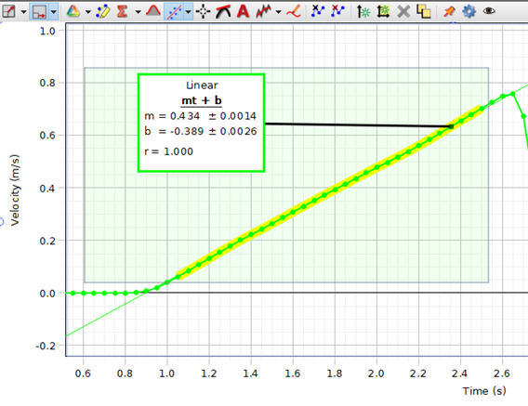
Figure 1: Velocity – Time Graph

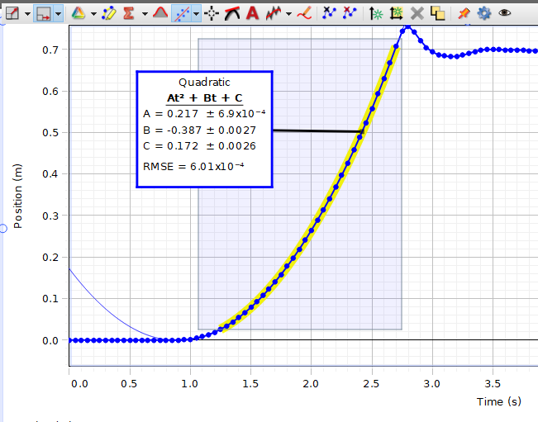
Figure 2: Position – Time Graph

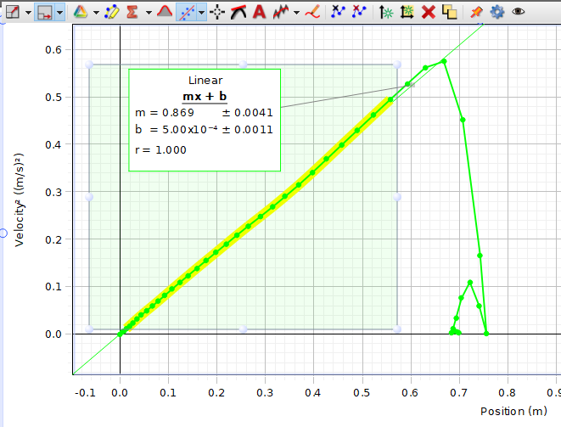
Figure 3: V² – Position Graph.

